Religious Beliefs Activate Neural Reward Circuits in Same Way As Sex and Drugs
Neuroscience NewsNovember 29, 2016
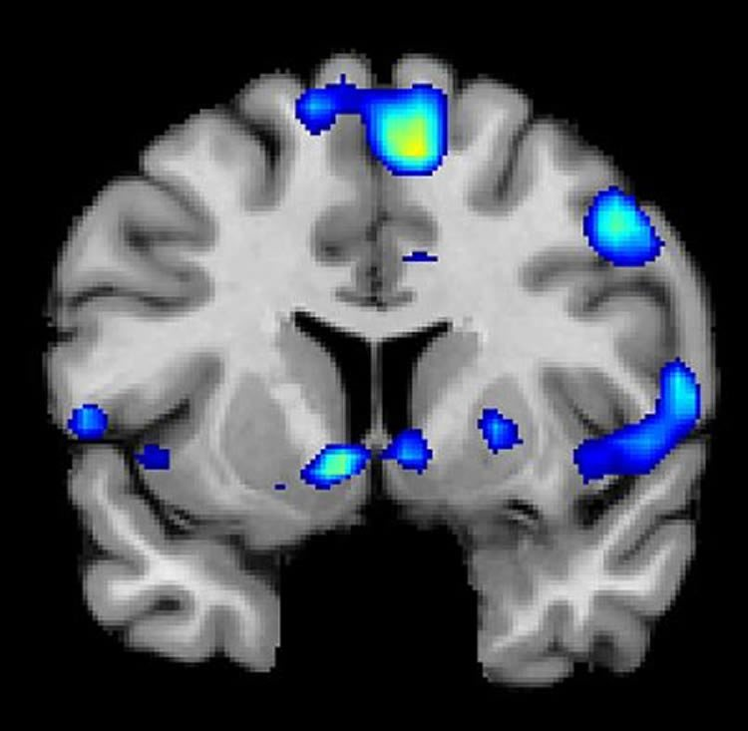
An fMRI scan shows regions of the brain that become active when devoutly religious study participants have a spiritual experience, including a reward center in the brain, the nucleus accumbens. NeuroscienceNews.com image is credited to Jeffrey Anderson.
Religious and spiritual experiences activate the brain reward circuits in much the same way as love, sex, gambling, drugs and music, report researchers at the University of Utah School of Medicine. The findings will be published Nov. 29 in the journal Social Neuroscience.
“We’re just beginning to understand how the brain participates in experiences that believers interpret as spiritual, divine or transcendent,” says senior author and neuroradiologist Jeff Anderson. “In the last few years, brain imaging technologies have matured in ways that are letting us approach questions that have been around for millennia.”
Specifically, the investigators set out to determine which brain networks are involved in representing spiritual feelings in one group, devout Mormons, by creating an environment that triggered participants to “feel the Spirit.” Identifying this feeling of peace and closeness with God in oneself and others is a critically important part of Mormons’ lives — they make decisions based on these feelings; treat them as confirmation of doctrinal principles; and view them as a primary means of communication with the divine.
During fMRI scans, 19 young-adult church members — including seven females and 12 males — performed four tasks in response to content meant to evoke spiritual feelings. The hour-long exam included six minutes of rest; six minutes of audiovisual control (a video detailing their church’s membership statistics); eight minutes of quotations by Mormon and world religious leaders; eight minutes of reading familiar passages from the Book of Mormon; 12 minutes of audiovisual stimuli (church-produced video of family and Biblical scenes, and other religiously evocative content); and another eight minutes of quotations.
During the initial quotations portion of the exam, participants — each a former full-time missionary — were shown a series of quotes, each followed by the question “Are you feeling the spirit?” Participants responded with answers ranging from “not feeling” to “very strongly feeling.”
Researchers collected detailed assessments of the feelings of participants, who, almost universally, reported experiencing the kinds of feelings typical of an intense worship service. They described feelings of peace and physical sensations of warmth. Many were in tears by the end of the scan. In one experiment, participants pushed a button when they felt a peak spiritual feeling while watching church-produced stimuli.
“When our study participants were instructed to think about a savior, about being with their families for eternity, about their heavenly rewards, their brains and bodies physically responded,” says lead author Michael Ferguson, who carried out the study as a bioengineering graduate student at the University of Utah.
Based on fMRI scans, the researchers found that powerful spiritual feelings were reproducibly associated with activation in the nucleus accumbens, a critical brain region for processing reward. Peak activity occurred about 1-3 seconds before participants pushed the button and was replicated in each of the four tasks. As participants were experiencing peak feelings, their hearts beat faster and their breathing deepened.
In addition to the brain’s reward circuits, the researchers found that spiritual feelings were associated with the medial prefrontal cortex, which is a complex brain region that is activated by tasks involving valuation, judgment and moral reasoning. Spiritual feelings also activated brain regions associated with focused attention.
“Religious experience is perhaps the most influential part of how people make decisions that affect all of us, for good and for ill. Understanding what happens in the brain to contribute to those decisions is really important,” says Anderson, noting that we don’t yet know if believers of other religions would respond the same way. Work by others suggests that the brain responds quite differently to meditative and contemplative practices characteristic of some eastern religions, but so far little is known about the neuroscience of western spiritual practices.

